IDS 401 Assignment 1 Variables and Classes

Please make sure that you submit your assignment on time. Submitting your assignment early is recommended, in case problems arise with the submission process. After you submit your assignment, you should also download and open the file you submitted to make sure everything is OK. Late submissions will be accepted but penalized up to one week after the submission deadline. After that, assignments will not be accepted.

Keep in mind, when you run into difficulties, try to google it. You may find someone answered the same question somewhere before.

1. Create a java file with name Checking, underscore, and your netID. For example, if your netID is batman1, your file name should be Checking_batman1. The objective of this assignment is to create a simple class for checking account.
2. Create a class, with same name as your file name (keep in mine the main class name should be consistent with your file name).
   1. There are two data members:
      1. An int variable *AccountNumber*
      2. A static float variable *InterestRate*
   2. There are two methods:
      1. *ChangAccNum*. This method will change the account number of corresponding object. This method should have one *int* parameter. There is no return value for this method. This method will take the value of the parameter and use this value as the new value of data member *AccountNumber*.
      2. *SetInterest*. This method will change the interest rate. This is a static method. It takes one float parameter. There is no return value. This method will take the value of the parameter and use this value as the new value of data member *InterestRate*.
      3. *Main method.* The entry point to the program, i.e., *public static void main(String[] args)*
   3. In the main methods:

*) Write several lines of code that takes three numbers as input (use *Scanner* class as we did in class) to calculate and print the average of the numbers. The program should look as following. Think about how you can use the println function to first print a string, then the value of a variable as below on the same line.

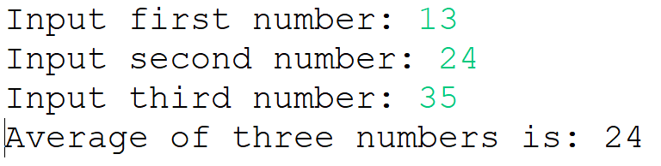

*) Write several lines of code that takes a string as input (use *Scanner* class as we did in class) and display the length of the string, and the third character of the string.

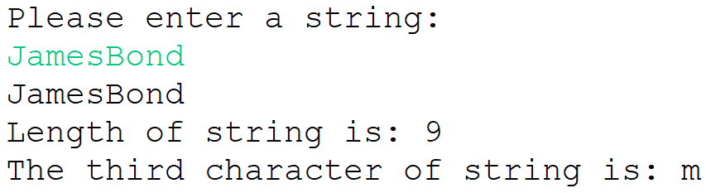

(Hint: if you use nextInt() method to read a number, you may need to use nextLine() method to clear user input).

*) Write several lines of code that first take one number as input (use *Scanner* class as we did in class. Hint: which method you should use when you expect a float number as input?). Then calls the *ChangAccNum* method and use the input number as parameter of this function (hint: how should you call this function? Should you create a new object and call this method using this object?)

*) Write several lines of code that first take one number as input (use *Scanner* class as we did in class). Then calls the *SetInterest* method and use the input number as parameter of this function (hint: how should you call this function? Should you create a new object and call this method using this object?)